## Instructions

You are given a Wokwi project with an Arduino simulator. A project is provided with assembled logic gates and flip flops.

#### Opening the project

The project is available at <https://wokwi.com/projects/381605497255007233>. If you wish to edit it, DO NOT make a public copy, edit it as it is and it will remain in your browser.

This exact project will be running on the validation servers.

#### About the setup

An Arduino Uno R3 is connected to logic gates, shift registers and flip flops. You can preview the setup with the Wokwi editor, which shows you a visualisation of the assembled circuit.

However, you will only be submitting the C++ code running on the Arduino. The circuit has been assembled on the servers as well, you cannot edit them as part of your submission.

You can write your code on the online editor, with syntax highlighting provided.

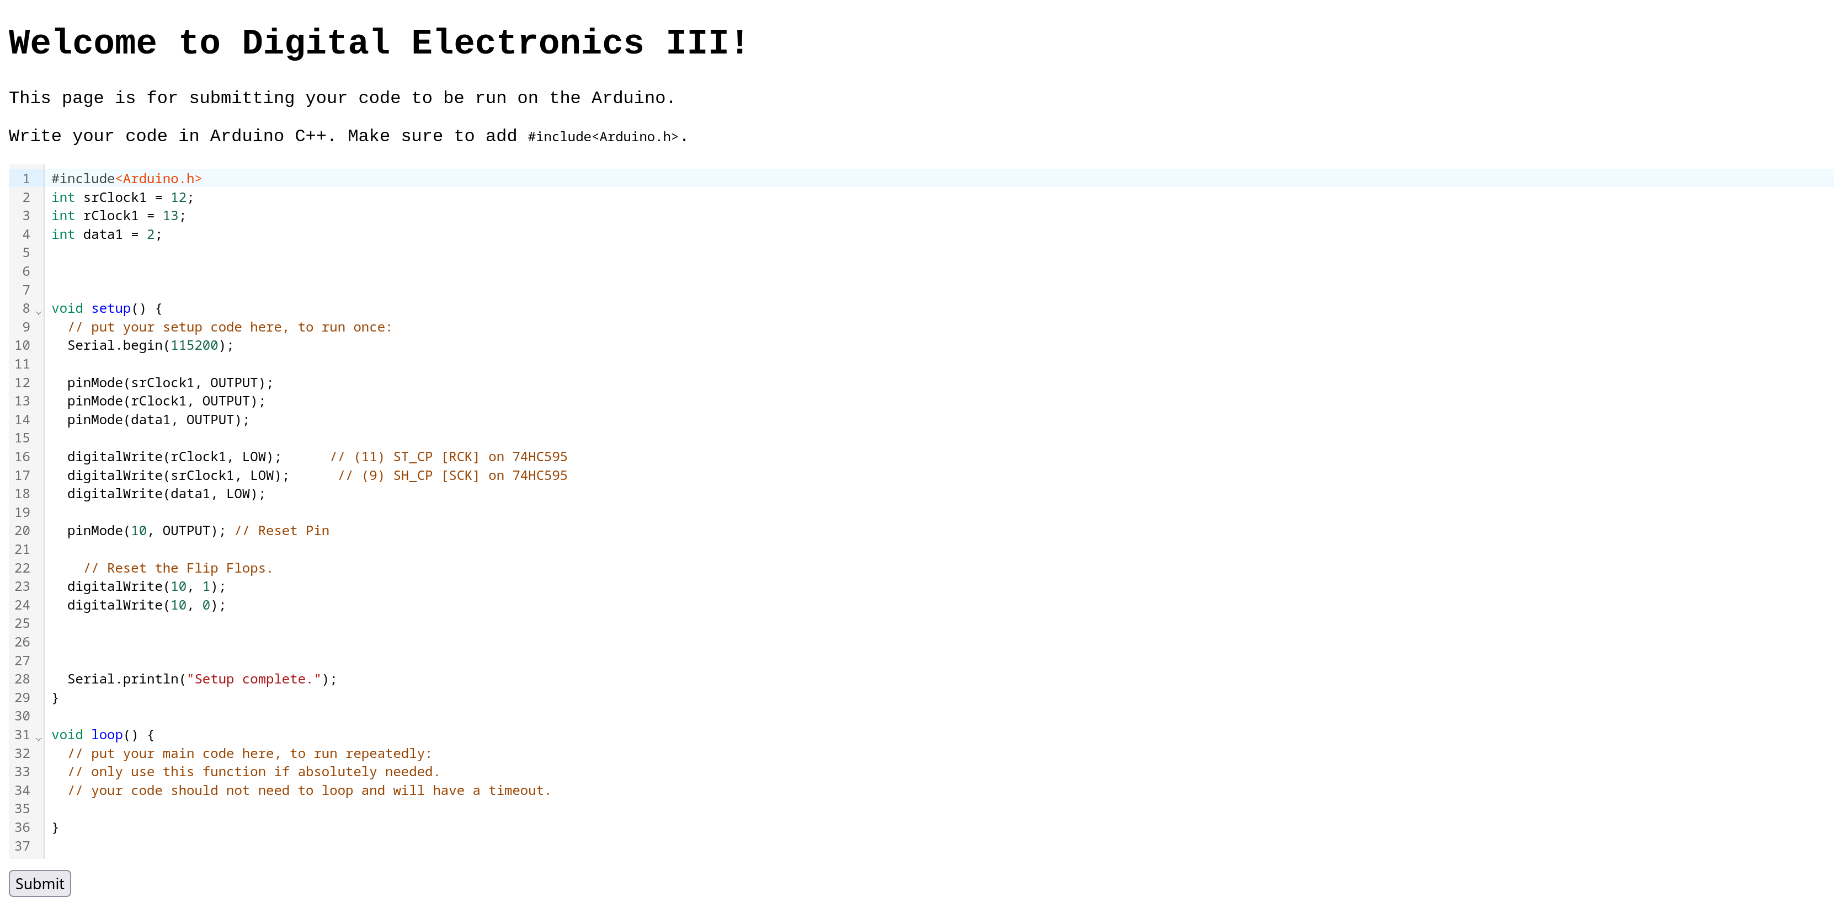

Press “Submit” to turn in your code. You are advised to use the submissions sparingly, for the benefit of other CTF players as simulation may be computationally expensive.

**Any DDoS of the system will not be tolerated.**

Your program will setup at the `setup` function.

Do note that your program MUST have an `#include<Arduino.h>` header if not compilation is guaranteed to fail. Use 112500 as the serial baud rate (Serial.begin(115200);)

Your program will be allowed to compile for as much time it requires. However, it will be limited to a runtime of 2 minutes, afterwhich the program will be stopped. The compilation system uses PlatformIO, and the program is being run on Wokwi CI.

There will be a validation system in place to verify that the outputs are indeed correct.

Once your program is sure the outputs are all correct, print a line “Setup complete.” with Serial.println.

#### Objective

Your objective is to write a C++ program for the Arduino, such that both outputs turn to logic HIGH (Boolean True, 1, 5V, etc.)

The outputs are at xor1 and not19. You will see them connected with red LEDs. The LED just serve an indicator.

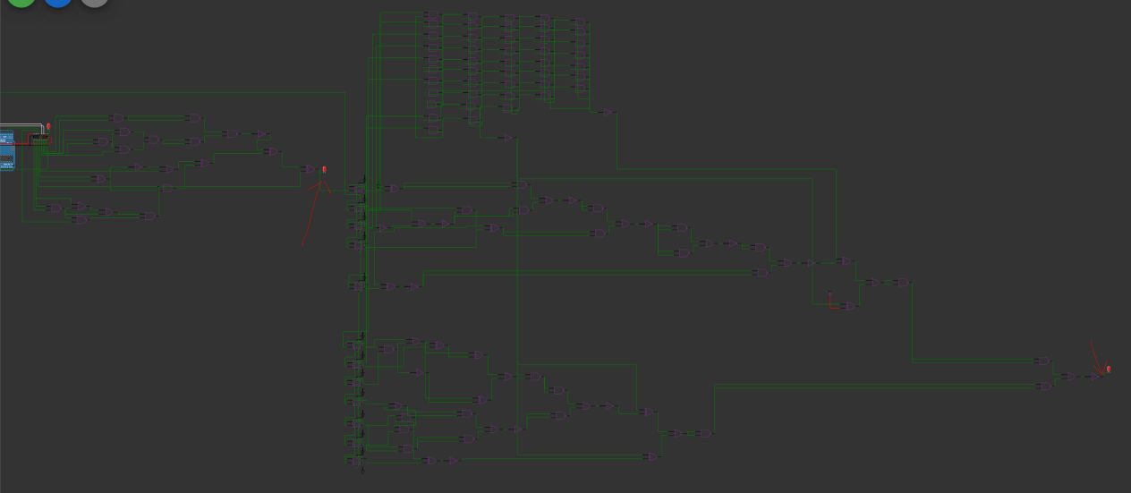

The outputs are shown in this screenshot.

You may use whatever tools available to solve this challenge. It is verified that this challenge is solveable.